# **SQL Queries**

1. KPI

## Total Revenue

SELECT ROUND(SUM(total price), 2) AS Total Revenue

FROM pizza sales;

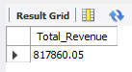

## 2. Average Order Value

SELECT ROUND(SUM(total price) / COUNT(DISTINCT(order id)), 2) AS "Average Value per Order"

FROM pizza sales;

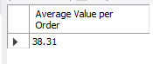

## 3. Total Pizzas Sold

SELECT SUM(quantity) AS "Total Pizza Sold"

FROM pizza sales;

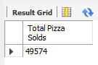

## 4. Total Orders

SELECT COUNT(DISTINCT(order id)) AS Orders placed

FROM pizza sales;

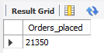

## 5. Average Pizzas Per Order

SELECT ROUND(SUM(quantity) / COUNT(DISTINCT(order id)),2) AS "Average Quantity per Order"

FROM pizza sales;

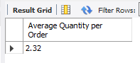

1. Daily Trends for Total Orders

SELECT

DAYNAME(order date) AS DAY,

COUNT(DISTINCT(order id)) AS Total orders

FROM pizza sales

GROUP BY DAY

ORDER BY Total orders DESC;

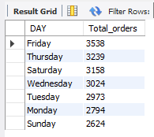

1. Monthly Trends for Orders

SELECT

MONTHNAME(order date) AS Month,

COUNT(DISTINCT(order id)) AS Total orders

FROM pizza sales

GROUP BY Month

ORDER BY Total orders DESC;

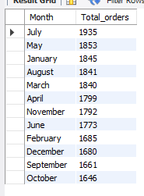

1. Percentage of Sales by Pizza Category

SELECT

pizza category,

ROUND(SUM(total price), 2) AS Total Revenue,

ROUND((SUM(total price) / SUM(SUM(total price)) OVER ()) * 100, 2) AS Percentage

FROM pizza sales

GROUP BY pizza category

ORDER BY Percentage DESC;

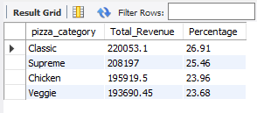

1. Percentage of Sales by Pizza Size

SELECT

pizza size,

ROUND(SUM(total price), 2) AS Total Revenue,

ROUND((SUM(total price) / SUM(SUM(total price)) OVER ()) * 100, 2) AS Percentage

FROM pizza sales

GROUP BY pizza size

ORDER BY Percentage DESC;

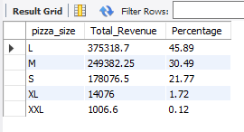

1. Total Pizzas Sold by Pizza Category

SELECT

pizza category,

SUM(quantity) AS Quantity Sold

FROM pizza sales

GROUP BY pizza category

ORDER BY Quantity Sold DESC;

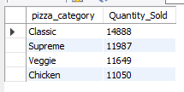

1. Top 5 Pizzas by Revenue

SELECT

pizza name,

ROUND(sum(total price),2) AS Total Revenue

FROM pizza sales

GROUP BY pizza name

ORDER BY Total Revenue DESC

LIMIT 5;

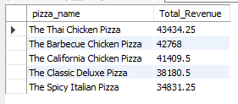

1. Bottom 5 Pizzas by Revenue

SELECT

pizza name,

ROUND(sum(total price),2) AS Total Revenue

FROM pizza sales

GROUP BY pizza name

ORDER BY Total Revenue

LIMIT 5;

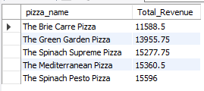

1. Top 5 Pizzas by Quantity Sold

SELECT

pizza name,

SUM(quantity) AS Total Pizzas Sold

FROM pizza sales

GROUP BY pizza name

ORDER BY Total Pizza’s Sold DESC

LIMIT 5;

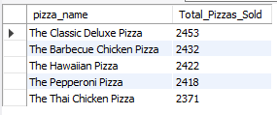

1. Bottom 5 Pizzas by Quantity Sold

SELECT

pizza name,

SUM(quantity) AS Total Pizzas Sold

FROM pizza sales

GROUP BY pizza name

ORDER BY Total Pizza’s Sold

LIMIT 5;

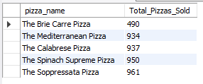

1. Top 5 Pizzas by Total Orders

SELECT

pizza name,

COUNT(distinct(order id)) AS Total Orders

FROM pizza sales

GROUP BY pizza name

ORDER BY Total Orders DESC

LIMIT 5;

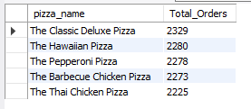

1. Bottom 5 Pizzas by Total Orders

SELECT

pizza name,

COUNT(distinct(order id)) AS Total Orders

FROM pizza sales

GROUP BY pizza name

ORDER BY Total Orders

LIMIT 5;

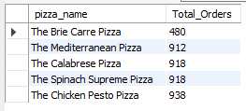

1. Top 5 Chicken Pizzas by Revenue

SELECT

pizza name,

ROUND(SUM(total price), 2) AS Total Revenue

FROM pizza sales

WHERE pizza category = 'Chicken'

GROUP BY pizza name

ORDER BY Total Revenue DESC

